|  |
| --- |
| **Downtime RFM 1# Top10 of Site high Downtime**    **Site_Name Downtime_hour Total_Rev Rev_Loss Backup_time(Mn) Distance(KM) Access_Time Battery**  1 XKG0061_XEKONG5_DAM 1,731.7 86,339,233 14,657,370 120 250.0 360 Batt  2 BLK0147_THONGMEXAY 1,163.2 198,647,787 8,895,821 10 88.0 240 Batt  3 LNT0039_DK14 615.3 453,062,396 15,282,920 480 60.0 120 Batt  4 SVN0255_LARDHOR 576.6 76,320,439 4,394,126 0 28.0 45 Gen  5 VTP0247_NONGSAN 560.4 172,827,147 16,875,006 60 98.0 240 Batt  6 LNT0097_BAN_NALEA_KAO 555.9 138,675,280 8,879,910 240 130.0 360 Batt  7 KHM0193_NASAIR 502.8 140,573,800 7,731,287 0 40.0 60 Batt no backup  8 XSB0030_NAMTHOUY 496.1 199,775,748 19,227,196 60 95.0 1,342 Batt & Gen  9 XSB0053_NAMXANB 490.8 158,560,020 4,880,194 0 8.0 1,830 No Batt  10 XSB0029_NAMPOUNG 480.3 99,865,012 7,056,387 40 69.0 976 Batt & Gen |

**2# Top10 of Site high Revenue Loss**

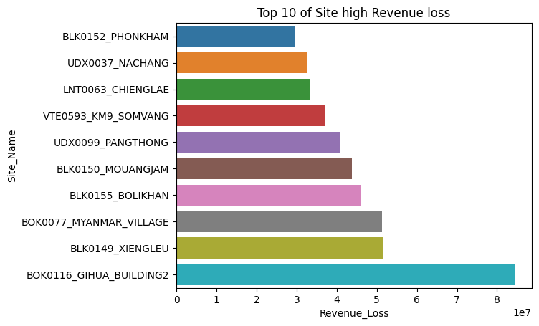

**Site_Name Revenue_Loss Total_Rev Downtime_hour Backup_time(Mn) Distance(KM) Access_Time Battery**

1 BOK0116_GIHUA_BUILDING2 84,456,519 2,169,248,822 14.9 230 10 20 Batt

2 BLK0149_XIENGLEU 51,617,025 927,123,722 166.3 60 124 180 Batt

3 BOK0077_MYANMAR_VILLAGE 51,228,163 2,355,034,466 26.2 190 10 20 Batt

4 BLK0155_BOLIKHAN 45,914,134 1,120,755,054 171.9 30 28 60 Batt

5 BLK0150_MOUANGJAM 43,742,911 577,259,001 25.9 30 162 240 Batt & Gen

6 UDX0099_PANGTHONG 40,782,675 786,619,563 180.1 120 75 110 Batt & Gen

7 VTE0593_KM9_SOMVANG 37,240,097 1,813,846,492 15.5 180 8 30 Batt

8 LNT0063_CHIENGLAE 33,269,620 781,615,021 197.5 30 65 120 Batt

9 UDX0037_NACHANG 32,532,810 432,757,447 245.3 30 22 60 Batt & Gen

10 BLK0152_PHONKHAM 29,702,337 346,441,534 238.7 10 195 300 Batt

**3# Top10 of Site high Usage but no improve Battery**

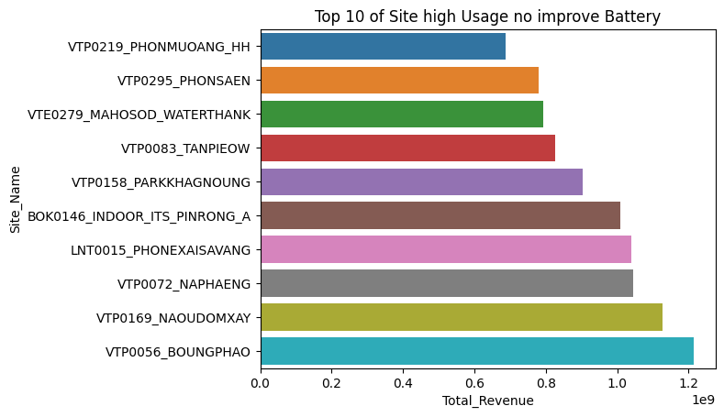

**Site_Name Total_Rev Revenue_Loss Downtime_hour Distance(KM) Access_Time Battery**

1 VTP0056_BOUNGPHAO 1,214,378,282 9,385,781 48.7 17 60 No Battery

2 VTP0169_NAOUDOMXAY 1,127,157,055 6,136,539 29.6 18 45 No Battery

3 VTP0072_NAPHAENG 1,044,384,161 1,956,550 10.1 45 90 No Battery

4 LNT0015_PHONEXAISAVANG 1,040,864,507 14,824,562 68.5 15 30 No Battery

5 BOK0146_INDOOR_ITS_PINRONG_A 1,008,217,299 1,392,805 13.8 10 20 No Battery

6 VTP0158_PARKKHAGNOUNG 903,719,593 3,127,892 15.4 12 20 No Battery

7 VTP0083_TANPIEOW 826,375,090 8,712,740 41.9 49 120 No Battery

8 VTE0279_MAHOSOD_WATERTHANK 793,698,907 1,708,551 10.3 2 10 No Battery

9 VTP0295_PHONSAEN 781,251,602 14,183,072 86.5 95 240 No Battery

10 VTP0219_PHONMUOANG_HH 686,532,246 15,887,892 116.9 48 120 No Battery

* **EDA**

**1# Province Downtime**

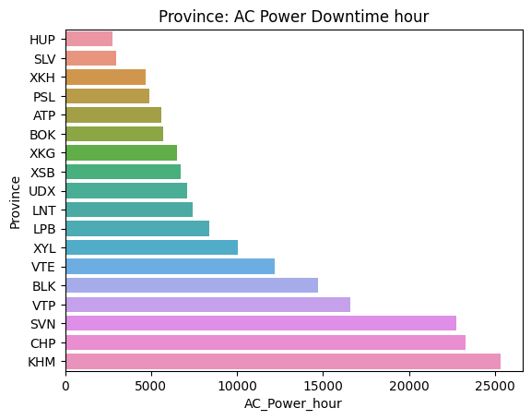

**2# KHM Downtime by District**

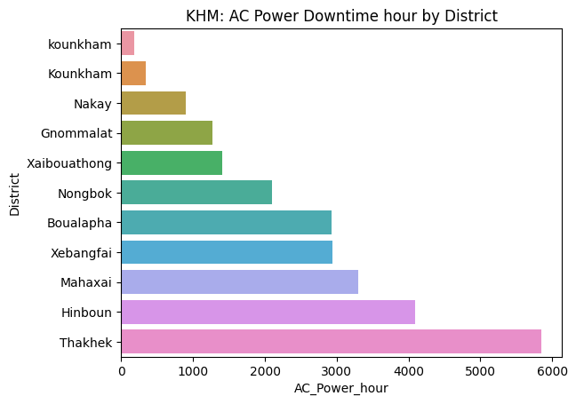

**3# Top10 KHM of Site high Downtime**

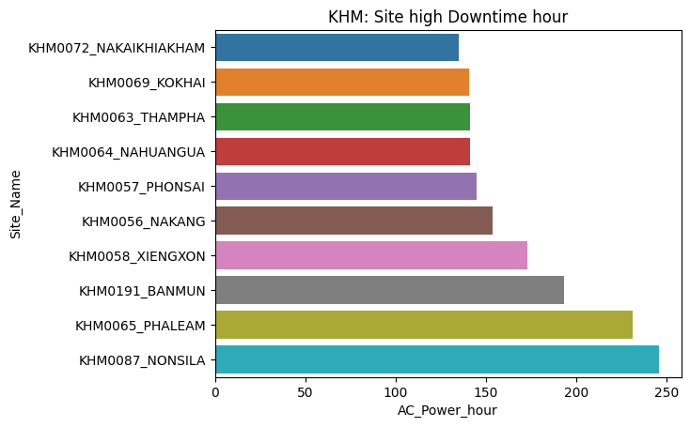

**4# Top10 KHM of Site high Downtime improve Battery**

**Site_Name Downtime_hour Total_Rev Rev_Loss Backup_time(Mn) Distance(KM) Access_Time Battery**

1 KHM0087_NONSILA 246.0 149,584,888 5,500,174 360 38 60 Batt

2 KHM0065_PHALEAM 231.5 207,592,993 9,497,636 30 40 55 Batt

3 KHM0191_BANMUN 193.3 121,011,161 1,867,659 0 70 120 No Battery

4 KHM0058_XIENGXON 172.9 259,915,063 10,957,446 60 35 45 Batt

5 KHM0056_NAKANG 153.7 379,879,650 12,626,266 20 38 50 Batt

6 KHM0057_PHONSAI 145.2 94,971,990 1,483,920 0 40 60 Batt no backup

7 KHM0064_NAHUANGUA 141.3 66,391,081 874,855 120 30 40 Batt

8 KHM0063_THAMPHA 141.1 83,133,652 2,323,929 60 10 25 Batt

9 KHM0069_KOKHAI 140.8 110,705,011 2,430,076 120 16 25 Batt

10KHM0072_NAKAIKHIAKHAM134.9 257,082,542 5,847,476 40 35 45 Batt